

FPT ACADEMY INTERNATIONAL
FPT – APTECH COMPUTER EDUCATION

Amazing Bridges

Class: T11907M0
Team: 4
Nguyen Thi Kim Tho (Team Leader) Student1215618
Ngo Thi Doan Dung Student1208495
Nguyen Thi Phuong Huyen Student1215623

Instructor:
Le Mong Thuy

October - 2019

This is to certify that
Mr./Ms.:
Nguyen Thi Kim Tho
Ngo Thi Doan Dung
Nguyen Thi Phuong Huyen
has successfully designed & developed
eProject: AmazingBridges.com Website
Submitted by:
Nguyen Thi Kim Tho
Date of issue:
07-Nov-2019
Authorised Signature:

Acknowledgement
This project consumed huge amount of work and dedication. Still, implementation would not have been possible if we did not have a support of many individuals. Therefore we would like to extend our sincere gratitude to all of them.
First of all we are thankful to Ms Le Mong Thuy for providing necessary guidance concerning projects implementation as well as her provision of expertise. Without her superior knowledge and experience, the Project could not have been successful. We also would like to express our sincere thanks towards the members of the team who devoted their time and knowledge in the implementation of this project.
Finally, we express our gratitude toward our families and colleagues for their kind co-operation and encouragement which help us in completion of this project.

Synopsis

Amazing Bridges is a website which provides information about various famous bridges around the world.
Amazing Bridges offers users the opportunity to learn more about World Bridges. All of the information is well organized and put into categories so it is very easy to search for and not time-consuming.
Amazing Bridges also allows its users to share their ideas with other people who have the same interest or even with the admin. Moreover, usefull information about buses and fights to reach the places is provided as well.

PROBLEM STATEMENT
Having read the project specifications, our team members realize that there are problems and difficulties which may interfere the users’ experience. In order to make the most precise decision and look for the best solution to tackle this, each developer has to consider the following querries thoroughly:
- How the structure of the site is displayed?
- How many categories are enough?
- How many bridges should be display on a page when they are grouped into categories?
- What information should be displayed on the homepage?
- How can the users interact with the website?
- How should the information about the bridges be shown on the page?
The website is to be developed for the Windows Platform using HTML5, JavaScript and Geolocation. The site should work well in all leading browsers including Chrome, IE, Firefox etc.
CUSTOMER'S REQUIREMENTS SPECIFICATIONS

Client: FPT_Aptech

Business / Project objective:
Provide users interesting information about famous bridges around the world.
Enable users to search for their favorite one through its name, all of the material can be downloaded from the website.
Help users to identify bridges location and find ways to reach there.

Input to the system:
From Webmaster:
- Details of some famous bridges.(features, history...including image).
- Location of the the bridges, buses and flights to to get to each monument.
- Contacts, mail.

From website visitors:
- Choice of the classified categories or request for a specific bridge information.
- Enter the names of the bridges which users would like to search.
- Users’ feedback.
Output from the system:
- Detailed information about the bridges as well as illustrated pictures .
- Display location of the bridges and provide information about buses, flight to reach the places.
- Export a .pdf or .doc file for users to download.
Hardware/ Software Requirements
Hardware
- A minimum computer system that will help you access all the tools in the courses is a Pentium 166 or better
- 64 Megabytes of RAM or better
Software
- Notepad/HTML editor
- Dreamweaver
- IE 5.0/ Netscape 6.0
Scope of the work (in brief):
After having a thorough discussion among members of the team, decision has been made to point out crutial requirements which need to be developed:
- All bridges are grouped into 4 categories
- At each site, show options like: word bridges, top bridge (longest, hightest, oldest), gallery, contact, about us.
- Homepages will show gallery of bridges and some outstanding bridges.
- User can give feedback and download file from the website
- Main features and histoy of the bridges will be presented on the webpage with pictures
Architecture and design of the system:
Windows platform device
Clients

HTML, CSS, Javascript, Jquery, Bootstrap
Server

Diagram of the website:
Begin

World Bridges
Advertisment
About us
Home
Gallery
Top Bridges
Contact
FAQ
Top Bridges
Top Bridges
Top Bridges

End

TASK SHEET REVIEW 1

Project Ref. No.:  eP/ Amazing Bridges website /04 |  | Project Title: | Activity Plan Prepared By: | Date of Preparation of Activity Plan:
Sr.  No. | Task | Project Title: | Activity Plan Prepared By: | Actual  Start Date | Actual Days | Team  Mate Names | Status
1 | Problem definition | Amazing Bridges | Tho | 07-Oct-19 | 1 | Tho, Dung, Huyen | Completed
2 | Requirement specification | Amazing Bridges | Tho | 07-Oct-19 | 1 | Tho, Dung, Huyen | Completed
3 | Architecture and design of the system | Amazing Bridges | Tho | 07-Oct-19 | 1 | Tho, Dung, Huyen | Completed
4 | Diagram of the website | Amazing Bridges | Tho | 07-Oct-19 | 2 | Tho, Dung, Huyen | Completed
5 | Task Sheet | Amazing Bridges | Tho | 07-Oct-19 | 2 | Tho | Completed

Date:
Signature of Instructor  Le Mong Thuy | Signature of Team Leader  Nguyen Thi Kim Tho

Site map:

HOME PAGE

WORLD BRIDGE
WORLD BRIDGE PAGE

INFORMATION PAGE ABOUT
LONGEST/ HIGHTEST/ OLDEST BRIDGES
TOP BRIDGE

GALLERY
GALLERY PAGE

CONTACT
CONTACT PAGE

ADVERTISMENT
ADVERTISMENT PAGE

ABOUT US
ABOUT US PAGE
FAQ
FAQ PAGE
Mock of the website:
1) Homepage:
 | Logo
 | Menu bar
 | Picture slideshow
 | Outstanding Bridges |  |  |  | Advertisement
 | images |  | Paraghraps |  | Advertisement
 | Footer

2) Word bridges, Top bridges (Top Highest, Top Longest, Top Oldest) page:
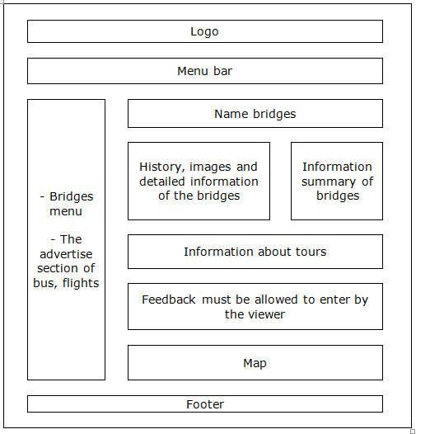

3) Gallery pages:

Logo
Menu bar
Picture slideshow
Detailed picture of bridges
Footer

4) Contact page:

Logo
Menu bar
Website information
Map
Footer

5) Advertisement page:

Logo
Menu bar
Website information
Footer

6) FAQ page:

Logo
Menu bar
Frequently Asked Questions
Footer

7) About us page:

Logo
Menu bar
Personal information of members in group
Footer

TASK SHEET REVIEW 2
Project Ref. No.:  eP/ Amazing Bridges website /04 |  | Project Title: | Activity Plan Prepared By: | Date of Preparation of Activity Plan:
Sr.  No. | Task | Project Title: | Activity Plan Prepared By: | Actual  Start Date | Actual Days | Team  Mate Names | Status
1 | Mock of the website | Amazing Bridges | Tho | 07-Oct-19 | 2 | Tho,  Dung,  Huyen | Completed
2 | Site map | Amazing Bridges | Tho | 07-Oct-19 | 1 | Tho,  Dung,  Huyen | Completed
3 | Task sheet | Amazing Bridges | Tho | 07-Oct-19 | 1 | Tho,  Dung,  Huyen | Completed

Date:
Signature of Instructor  Le Mong Thuy | Signature of Team Leader  Nguyen Thi Kim Tho

